**Linux Commands**

**Running Basic Linux Commands on an AWS EC2 Ubuntu Instance**

*“This lab is conducted on an AWS EC2 instance running Ubuntu OS. The goal is to execute and understand fundamental Linux commands."*

**ubuntu@ip-172-31-7-106:~$**

***Ubuntu –*** *This is the username of the current user logged in to the system. In this case, the user is ubuntu.*

***@ - Seperator -*** *This separates the username from the hostname of the machine.*

***ip-172-31-7-106 -*** *This is the hostname of the system. It is EC2 instance machine with an IP address of 172.31.7.106 (I am running Ubuntu Linux on AWS for this practical ).*

***~ -*** *This represents the current working directory, ~ is a shortcut for the user's home directory. So, the user is currently in their home directory.*

***$ -*** *This symbol indicate non-privilege/ non-root user, ( # indicate root/privilege user). This is the command prompt also this symbol, indicating that the system is ready for us to enter a command.*

**date**: Displays the current date and time.



**whoami :** To display the current username.



**cd <directory_name>**: (Change Directory) Changes to the specified directory. [Here ( / ) is root directory for root user]



**ls**: (List Segment) Lists all files and directories in the current directory.



**ls -a**: Shows hidden files (hidden files in linux are starting with a dot).

**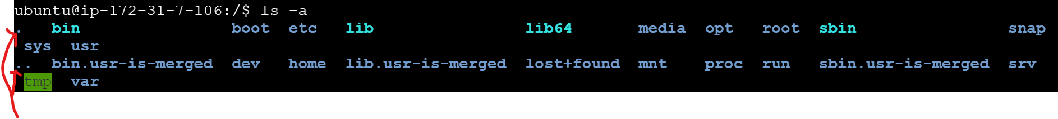***Here dots indicate hidden files*

**ls -l**: Lists files and directories along with permissions, size, owner, group, date and time of last modification.

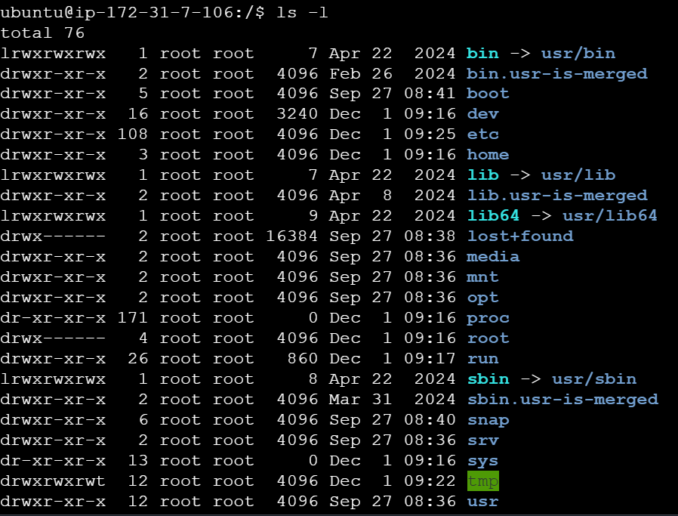

**pwd**: (Print Working Directory) Displays the full path to the current directory.



**cd ..** : Moves one level up to the parent directory (you are currently in the directory /home/ubuntu/document. If you run the command (cd ..)You will be moved up one level to /home/ubuntu, as this is the parent directory of /home/ubuntu/document. If you run cd .. again from /home/user, you will move up another level, and the directory will change to /home, which is the parent of /home/ubuntu. If you run cd .. when you're at the root directory /, nothing will happen because / is the top-level directory and does not have a parent.)



**mkdir <directoryname>**: (Make Directory) Creates a new directory in the current working directory.

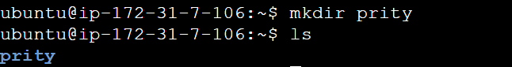

*Make multiple directories at same time.*



**cat <filename>**: (Concatenate) Displays the content of a file or creates a new file. [cat > filename , a file will create we and come inside the file we can write in file, to come out from file , press ctrl + d ]

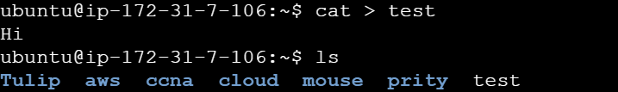

Now to see content of file use command (cat filename).



**touch <filename>**: Creates a new empty file (when create file using touch command empty file will create )



*Create multiple empty file same time.*



**rm <filename>**: (Remove) Deletes the specified file.

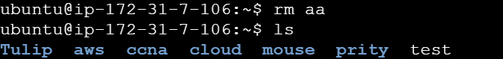

*Delete multiple files same time.* 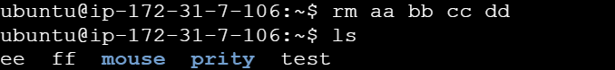

**rmdir <directoryname>**: (Remove Directory) Deletes an empty directory.

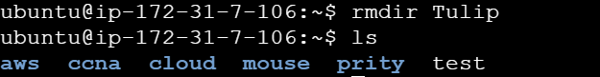

*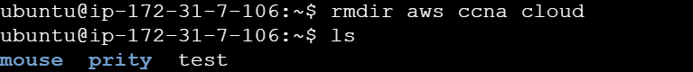To remove multiple directories at same time, after rmdir type all directories name you want to delete.*

**cp <source> <destination>**: (Copy) Copies a file or folder from the source to the destination. (cp command not deletes source file.)

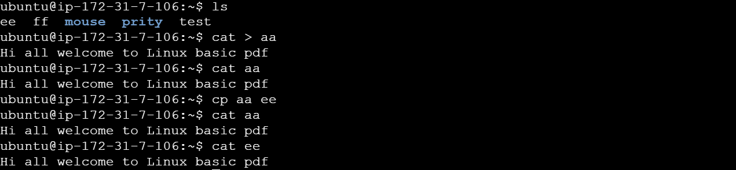

**mv <source> <destination>**: (Move) Moves a file or folder from the source to the destination or rename it. (mv deletes the source file or directory after moving it)

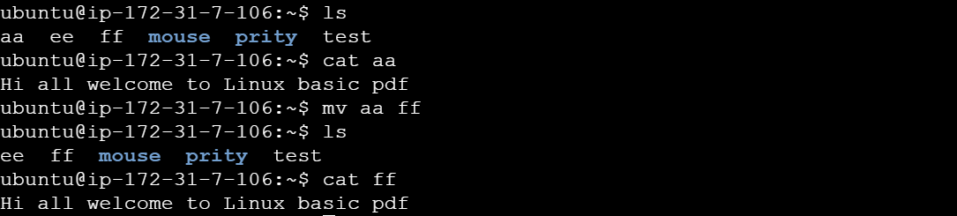

**ps**: Displays currently active processes.

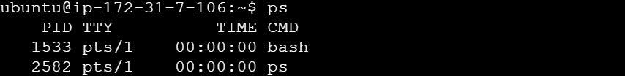

*Useradd <username> : To add new user. (check user entry in file /etc/passwd)*



**chown <ownername> <filename>:** (Change Owner) Changes the owner of a file.

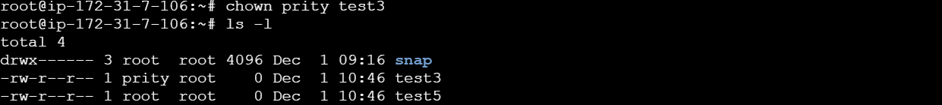

**top:** (Table of processes) Displays all running processes in real-time.

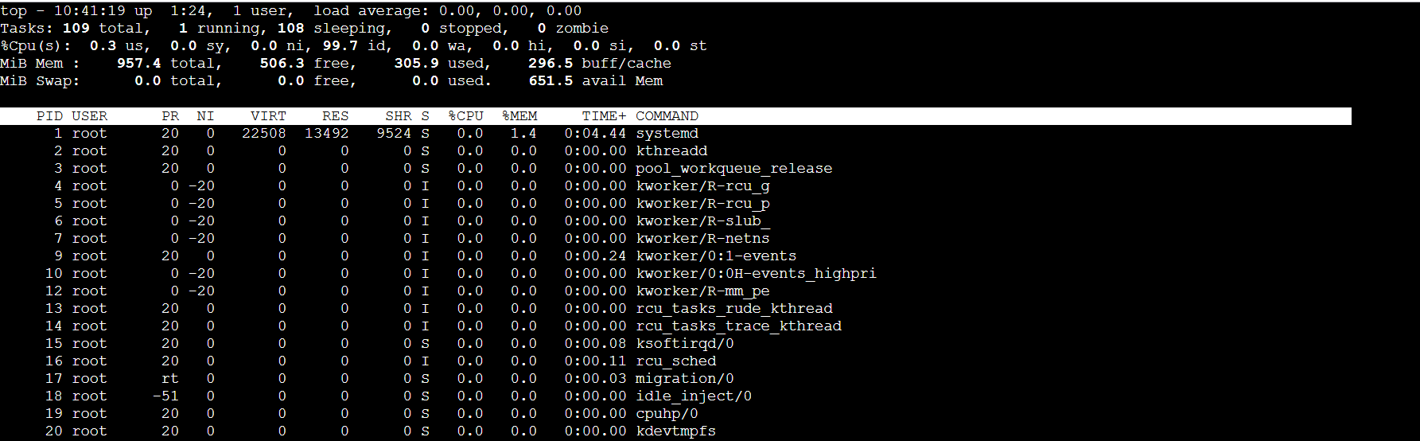

**grep <pattern> <files>:** (Global Regular Expression Print) Searches for a pattern in files.



**echo 'text'**: Prints text to the console.



**diff <file1> <file2> : (Difference**) Compares two files and shows the differences.

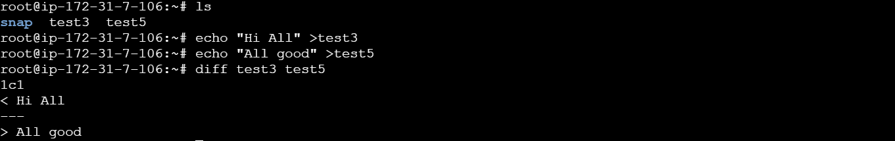

**wc <filename>:** (Word Count) Counts lines, words, and characters in a file.

**

**df**: (Disk Filesystem) Shows disk usage for file systems.

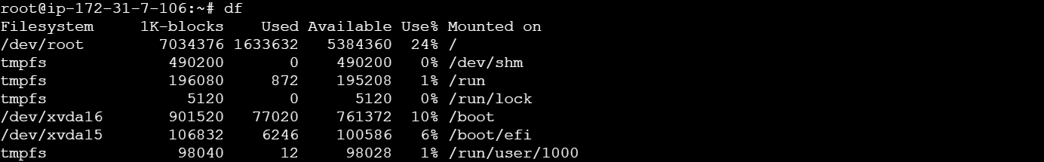

**df -h**: Shows disk usage in a human-readable format.

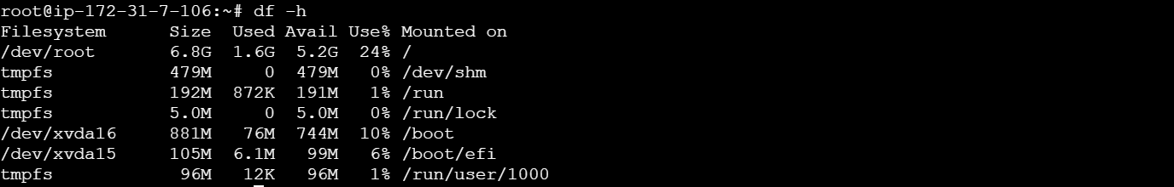

**du –sh <file/folder>**: (Disk Usage) See the size of file and folder.



**free**: Displays memory and swap usage.



**date**: Displays the current date and time.



**uptime**: Shows system uptime.



**hostname:** See the host name.



***history:*** *Display all used commands.*

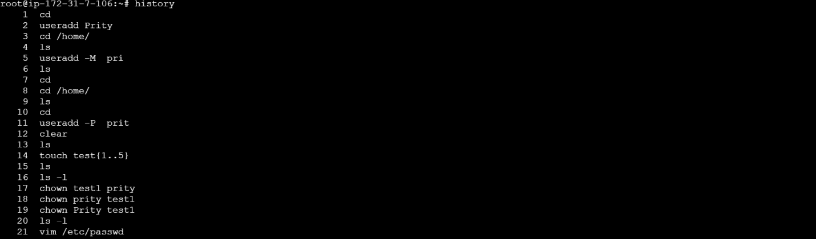

***ls –i:*** *Show file and folders with name and inode number*.



uname : To see the Kernal name.



uname –r: Display kernel version.



**Shortcuts :**

|  |  |
| --- | --- |
| **Command** | **Description** |
| **ctrl+c** | **Terminates a process.** |
| **ctrl+z** | **Stop a process and puts it in the background.** |
| **ctrl+d** | **Logs out from the current session.** |
| **ctrl+l** | **Clears the terminal screen.** |
| **tab** | **Auto- completes file/ directory names** |